**EXPERIMENT NO – 3**

**a) Program for identifying odd / even / prime numbers**

# 3_A - odd even prime

#program to identify inputed no is odd or even

x =int(input("enter a no:"))

if x%2==0:

    print(x," is even!!")

else:

    print(x," is odd!!")

#program to identify given no is prime or not

x1 =int(input("enter a no:"))

for y in range(2,x1):

    if x1%y==0:

            print(x1," is not prime")

            break

else:

    print(x1," is prime")

**OUTPUT:**

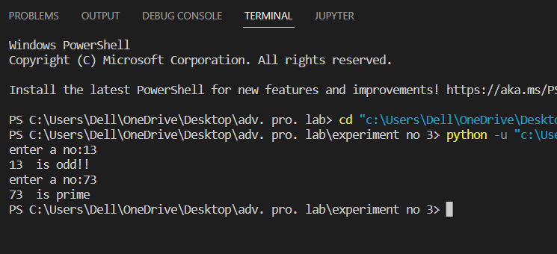

**b) Program for income Tax calculation based on salary**

#for income = 250000 no tax,,, for income in bet 250000-500000 tax will be 5%,,

# for 500000-800000 tax 15%,,for above than 8lakh tax 30%

income=int(input('enter your total income:'));

if income<=250000:

     tax=income*(0/100);

     print('tax amout=',tax);

elif income>250000 and income<=500000:

     gross=income-250000;

     tax=gross*(5/100);

     print('tax amount=',tax)

elif income>500000 and income<=800000:

     gross=income-250000;

     gross1=gross-250000;

     tax1=250000*(5/100)

     tax2=gross1*(15/100)

     tax=tax1+tax2;

     print('tax amount=',tax)

else:

     gross=income-250000;

     gross1=gross-250000;

     gross2=gross1-300000;

     tax1 = 250000 * (5 / 100)

     tax2 = 300000 * (15 / 100)

     tax3 = gross2 * (30 /100)

     tax=(tax1+tax2+tax3)

     print('tax amount=', tax);

**OUTPUT:**

